SAMARA STATE MEDICAL UNIVERSITY
DEPARTMENT OF GENERAL AND CLINICAL PATHOLOGY:
PATHOLOGICAL ANATOMY, PATHOLOGICAL PHYSIOLOGY
STUDENT SCIENTIFIC SOCIETY
SNK "SEEKERS OF THE ESSENCE" OF THE DEPARTMENT OF GENERAL AND CLINICAL PATHOLOGY



MODERN PATHOLOGY:
EXPERIENCE, PROBLEMS, PROSPECTS

April 11-12, 2025

Dear colleagues!
Samara State Medical University invites you to participate in the V All-Russian Scientific and Practical Conference with international participation
"Modern pathology: experience, problems, prospects",
dedicated to the memory of Professor Nikolai Fyodorovich Shlyapnikov

VENUE:
Samara, Samara State Medical University

PARTICIPATION FORM:
Correspondence: publication of an article
Full-time: presentation with the publication of the article

CONFERENCE LANGUAGES:
Russian, English

Based on the results of the conference, the program and collection of materials (RSCI Science Citation Index) will be published. The collection will include works that have received a positive assessment from the editorial board.

MAIN CONFERENCE WORK AREAS:
- Problems of pathological anatomy
- Problems of pathological physiology
- Problems of forensic medical examination
- Fundamental issues of medical science
- History of pathology
- Current problems of pathology (section in English)

The program also includes works on pathology in obstetrics and gynecology, therapy, surgery, dentistry, pharmacotherapy and other areas of medical science.
A detailed and scientifically based description of the pathogenesis and/or pathomorphology in the manuscript is a prerequisite

Organizing Committee
Organizing Committee chairs:
Kolsanov Alexander Vladimirovich – University Rector, Professor of the Russian Academy of Sciences, Honored Scientist of the Russian Federation, Doctor of Medical Sciences, Professor
Davydkin Igor Leonidovich– Research Director, Winner of the Russian Government Prize, Doctor of Medical Sciences, Professor
Ivanov Mikhail Fedorovich – Head of the Department of General and Clinical Pathology, Candidate of Medical Sciences, Associate Professor
Fedorina Tatyana Alexandrovna – Professor of the Department of General and Clinical Pathology, Honored Worker of the Higher School of the Russian Federation, Doctor of Medical Sciences, Professor
Members of the Organizing committee:
Yunusova Yulia Rafailevna – Associate Professor of the Department of General and Clinical Pathology, Candidate of Medical Sciences
Isakova Natalia Victorovna – Associate Professor of the Department of General and Clinical Pathology, Candidate of Medical Sciences
Shatunova Elena Petrovna – Professor of the Department of General and Clinical Pathology, Doctor of Medical Sciences
Sukhachev Pavel Anatolievich – Associate Professor of the Department of General and Clinical Pathology, Candidate of Medical Sciences
Larina Tatyana Viktorovna – Chief Freelance specialist of the Ministry of Health of the Samara Region on Pathological Anatomy, Excellent Healthcare Worker of the Russian Federation
Yashin Sergey Sergeevich – Senior Lecturer of the Department of General and Clinical Pathology

PARTICIPATION IN THE CONFERENCE:

- Employees of educational organizations, practicing doctors, young scientists, postgraduates, clinical residents, and students of higher educational institutions can take part in the Conference.
- The results of original studies, наscientific reviews, and clinical cases are accepted for publication.
- Materials of reports will be accepted in electronic form together with the application form (Appendix 1) to the following address: n.v.isakova@samsmu.ru to March, 15, 2025, inclusive. Example file names: SergeevS.S_application, SergeevS.S_article, SergeevS.S_article2, SergeevS.S_figure1, SergeevS.S_figure2

DESIGN REQUIREMENTS

- The total volume of the material is not less than 4 and not more than 8 pages. A larger volume of material can be accepted by the editorial board, if this is justified.
- The design is done in the Microsoft Office Word text editor.
- Font- Times New Roman.
- The font size of the entire text is 12 pt.
- Single line spacing, before – 0 pt, after – 0 pt.
- The field width is 2 cm on the left, 2 cm on the top and bottom, and 2 cm on the right.
- Paragraph indent – 1.25 cm.
- Alignment of the Title – in the center, the main text-in width.
- 1st line – UDC (you need to find the code corresponding to the topic of publication using the site: https://teacode.com/online/udc/)
- 2nd line – the name of the work – in CAPITAL BOLD letters.
- 3rd line – surname and initials of the author (s) – in bold italics.
- 4th line – name of the institution, city, country – in italics.
- 5th line – division name – in italics.
- 6th line (for student papers) – supervisor. After the words "Scientific supervisor", put a colon, indicate the academic degree and academic title (if absent-the position), initials and surname of the scientific supervisor.
- After the title, indent one line and then follow the text of the work.
- In the text of the work, it is necessary to select a summary – no less than 100 and no more than 200 words, including ashort, unstructured description of the main problems considered in the work and the results of the work. The word "Summary" is written in bold, and the text of the abstract follows from a new line.
- Keywords: no less than 3 and no more than 5 basic concepts that can be used to understand the direction of work. "Keywords" should be written in bold, followed by a colon and then followed by keywords separated by commas.
- Custom structuring by sections and parts is possible.
- The summary, keywords and main text of the work should be given in full in Russian or English. Works written in English imply a presentation in English.
- Figures are inserted into the text of the article (text wrapping is set in the settings – no) and additionally sent as separate files.
- Micrographs must be signed with an indication of the histological color and magnification. Tables are executed in the Microsoft Office Word text editor and should not extend beyond the margins. Figure names and numbers are indicated below the figures (center alignment, bold), table names and numbers are indicated above the tables (right alignment, bold).
- Tables and figures should be placed on the page in portrait orientation. Placement of content in landscape orientation is only possible by agreement.
- The Editorial Board reserves the right to edit the texts of manuscripts with correction of grammatical, punctuation and other errors without changing the meaning of the text.
- Manuscripts that do not meetthe design requirements and/or have obvious signs of plagiarism will not be accepted for publication. For such works, the editorial board will give a reasoned refusal to publish the work with the possibility of re-submission after correcting design errors and / or eliminating questions about the originality of the text.
- Not allowed:
* page numbering.
* use page breaks in the text.
* use of automatic paginated links.
* use of automatic transfers.
* use sparse or compacted letter spacing.

Creating a list of references
- The list of references should include the most significant and relevant works on the topic of the article. It is recommended to include at least 50% of the works published in the last 5 years in the list of references.
- References to sources are given in square brackets directly in the text of the article. Each source in the list of references should be mentioned in this way. If a reference is made to more than 2 consecutive items in the list of references, they should be separated by a hyphen, for example: [1-3].
- The link is provided as part of a sentence, i.e. punctuation marks are placed after the link:

The current approach generally considers all clear-cell tumors to be carcinomas, but there are studies [5] that indicate the need for a clear differentiation of clear-cell tumors by malignancy potential with the allocation of (conditionally) benign tumors or precancerous conditions [6, 7]. Therefore...

- The list of references is formed as they are mentioned in the text, and not in alphabetical order.
- The citation volume is determined by the author, but the total number of sources in review papers should be limited to 50, and in original studies and clinical case descriptions to 30.
- The link formatting format resembles the AMA format, with minor differences:
- The authors ' surnames and initials are indicated first. For sources in Russian, it is mandatory to include dots after each initial. For foreign sources, don't put dots after their initials. Don't put a space between the initials of the first and last names.
- If there are less than 5 authors in the cited source, all authors are indicated. Otherwise, the first 5 authors are indicated, followed by "et al. "or"et al. " for Cyrillic and Latin sources, respectively.
- If the journal has an abbreviated name in the Index Medicus, then specify it. Otherwise, enter the full name of the journal. The names of Russian journals should not be abbreviated.
- If the publication has a doi, then it is advisable to specify it.

Sample design in Russian:
Шилова А.С., Шмоткина А.О., Яфарова А.А., Гиляров М.Ю. Синдром такоцубо: современные представления о патогенезе, распространенности и прогнозе. Рациональная фармакотерапия в кардиологии. 2018;14(4):598-604. doi: 10.20996/1819-6446-2018-14-4-598-604

Example of Latin script formatting:
Gjeorgjievski M, Cappell MS. Portal hypertensive gastropathy: A systematic review of the pathophysiology, clinical presentation, natural history and therapy. World J Hepatol. 2016;8(4):231-262. doi: 10.4254/wjh.v8.i4.231

- References to monographs, books, and parts of them should only be made with the publisher and year of publication.

Sample design in Russian:
Озолиня Л.А., Керчелаева С.Б., Лапина И.А. и др. Венозные тромбоэмболические осложнения в акушерстве и гинекологии. 2-е изд. М.: ГЭОТАР-Медиа; 2020.
Example of Latin script formatting:
Rana AQ, Chou KL. Essential Tremor in Clinical Practice. Springer; 2015.

- References to dissertation abstracts, textbooks, and teaching aids are not allowed.

Publication of scientific work is free of charge. The electronic version of the conference program and the collection of materials will be posted on the website of Samara State Medical University (https://samsmu.ru/events/2025/1104/)

The text of the article is accompanied (in a separate file in Word format) by information about the author(s) in the form of an application (see appendix 1).

Contact information:

 | Yulia Rafailevna Yunusova,  Associate Professor of the Department of General and Clinical Pathology,  Candidate of Medical Sciences |  | +7909-344-45-67-344-45-67  (Viber, WhatsApp, Telegram) |  | yu.r.yunusova@samsmu.ru.r.yunusova@samsmu.ru
 | Sergey Sergeevich Yashin,  Senior Lecturer of the Department of General and Clinical Pathology |  | +7927-739-42-10-739-42-10  (Viber, WhatsApp, Telegram) |  | s.s.yashin@samsmu.ru.s.yashin@samsmu.ru
 | Lyudmila Trots,  head of the SSK "Seekers of the Essence" of the Department of General and Clinical Pathology |  | +7927-750-38-60 |  | https://vk.com/corpse_anarchict

Design example:
UDC 616.24-005.7

EVALUATION OF THE EFFECTIVENESS OF MEASURES FOR THE PREVENTION OF PE IN PATIENTS OF A MULTIDISCIPLINARY HOSPITAL
N.A. Kopaeva, V.I. Makarova
Samara State Medical University, Samara, Russia
Department of General and Clinical Pathology: Pathological Anatomy, Pathological Physiology
Scientific supervisors: Candidate of Medical Sciences, Associate Professor Yu.R. Yunusova, Senior lecturer S.S. Yashin

Summary
TextText text text text text text text text text text text text text text text text text text text text text text text text text text text text text text text text text text text text text text text text text text text text text text text text text text text text text text text text text text text text text text text text text text text text text text text text text text text.
Key words: first, second, third, fourth

Introduction
Text text text [1].
Text text text [2-4].
Text text text [1, 2, 5-8].

Table 1. Comparative characteristics of PE frequency

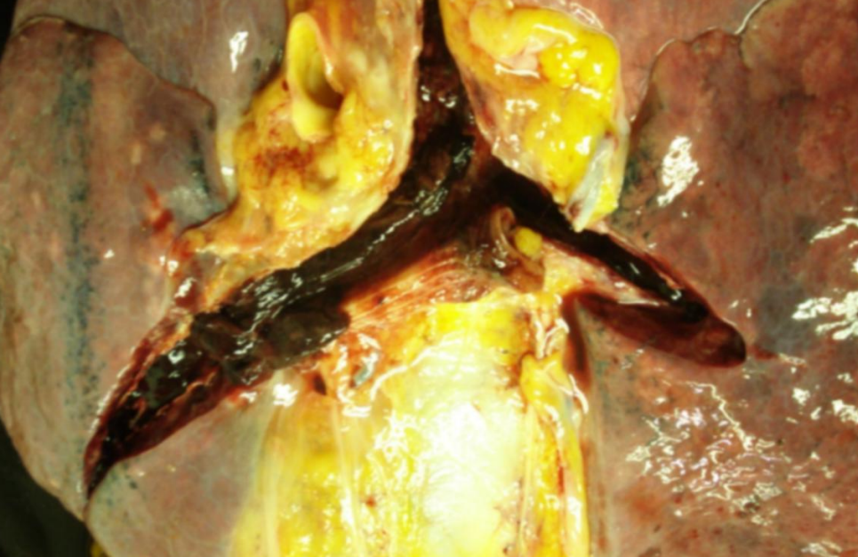
Figure 1. Thromboembolism in the pulmonary trunk.

Conclusion
Text text text

References
1. Yashin S. S., Isakova N. V., Shatunova E. P., Yunusova Yu. R., Shuvalova T. V., Larina T. V., Kopaeva N. A., Makarova V. I. Pathogenetic features of pulmonary embolism. Modern problems of science and education. 2020;(5):111.
2.

Appendix 1

Application
to participate in the V All-Russian Scientific and Practical Conference
"Modern pathology: experience, problems, prospects"

1. Information about the author – s) - filled in for each author!

1. | Last Name First Name Patronymic  (in full)
2. | Course, faculty /  Place of work, position
3. | Name of the organization (in full), city
4. | Contact phone  number(you can specify one for all authors)
5. | E-mail address (you can specify one for all authors)

2. Information about the supervisor (if any)

1. | Last Name First Name Patronymic  (in full)
2. | Place of work, position
3. | Full name of the organization, city

3. Publication name

4. Participation form

The "Face-to-face" form of participation provides for a speech at the conference in the format of an oral report with a presentation or other visual materials. Due to the need to form the program of the face-to-face event in advance, the Organizing Committee strongly recommends that you immediately decide on the form of participation. If you have specified the full-time form of participation, but due to certain circumstances you will not be able to attend, please notify the Organizing Committee as early as possible. The time of the report is strictly regulated: for students – no more than 7 minutes, for young scientists, doctors, teachers and researchers – no more than 15 minutes.

The form of participation "Correspondence" provides only for the publication of the work in the collection of materials and inclusion in the general program of the event.

Completing the application means agreeing to publish the article in the conference proceedings and publishing metadata in the conference program "Modern Pathology: experience, Problems, Prospects"
Contact details will only be used by members of the organizing committee to contact the authors

